PRESS RELEASE
Title
City (Country), 01st Month YYYY
[Lead paragraph… enter text]

[Press release text]

“Quote"
Title and Name

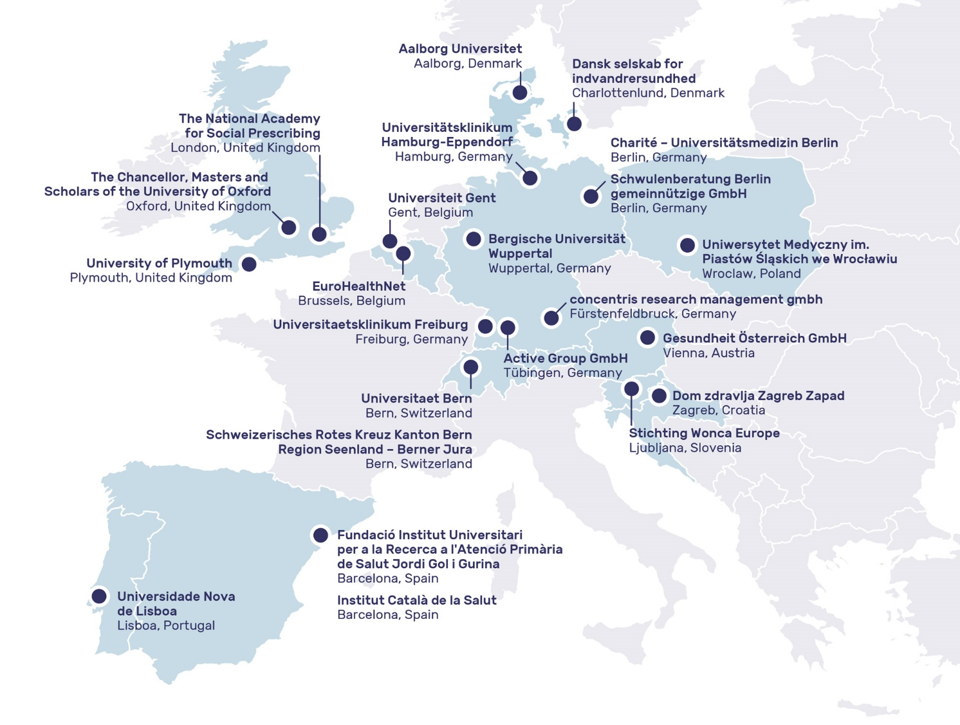
Caption: Within the SP-EU consortium, 22 institutes across Europe join forces for 5 years (from January 2025 to December 2029) to improve access to health and care services for LGBTIQ people, refugees and first-generation immigrants as well as older adults who live on their own.

social-prescribing.eu | www.linkedin.com/company/social-prescribing-eu | 

Contact
Charité Universitätsmedizin Berlin
Institute of General Practice and Family Medicine
Prof. Wolfram Herrmann
Charitéplatz 1
10117 Berlin
Germany
wolfram.herrmann@charite.de
Funding
Views and opinions expressed are however those of the author(s) only and do not necessarily reflect those of the European Union or European Health and Digital Executive Agency (HADEA). Neither the European Union nor the granting authorities can be held responsible for them. Grant Agreement No 101155873. | 

